C:\Users\Sakshi Rathi>mongosh

Current Mongosh Log ID: 684673b9295b637b8f6c4bcf

Connecting to: mongodb://127.0.0.1:27017/?directConnection=true&serverSelectionTimeoutMS=2000&appName=mongosh+2.5.1

Using MongoDB: 8.0.9

Using Mongosh: 2.5.1

mongosh 2.5.2 is available for download: https://www.mongodb.com/try/download/shell

For mongosh info see: https://www.mongodb.com/docs/mongodb-shell/

------

The server generated these startup warnings when booting

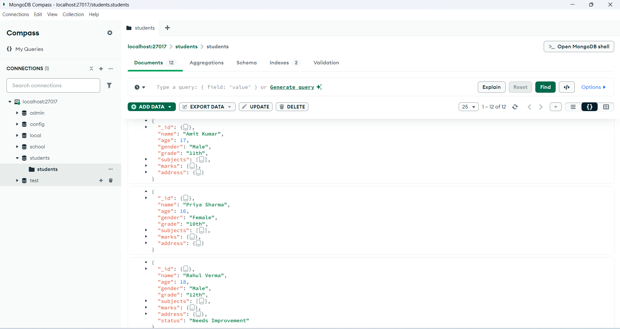 2025-06-06T15:19:23.057+05:30: Access control is not enabled for the database. Read and write access to data and configuration is unrestricted

test> **use students**

switched to db students

**Q1. Insert 5 student records**

students> db.students.insertMany([

... {

... name: "Amit Kumar",

... age: 17,

... gender: "Male",

... grade: "11th",

... subjects: ["Math", "Physics", "English"],

... marks: { Math: 82, Physics: 91, English: 75 },

... address: { city: "Delhi", pincode: "110001" }

... },

... {

... name: "Priya Sharma",

... age: 16,

... gender: "Female",

... grade: "10th",

... subjects: ["Biology", "English", "Chemistry"],

... marks: { Biology: 78, English: 69, Chemistry: 88 },

... address: { city: "Mumbai", pincode: "400001" }

... },

... {

... name: "Rahul Verma",

... age: 18,

... gender: "Male",

... grade: "12th",

... subjects: ["Math", "Computer", "English"],

... marks: { Math: 35, Computer: 95, English: 92 },

... address: { city: "Delhi", pincode: "110002" }

... },

... {

... name: "Sneha Reddy",

... age: 17,

... gender: "Female",

... grade: "11th",

... subjects: ["Math", "Physics", "Chemistry"],

... marks: { Math: 88, Physics: 37, Chemistry: 41 },

... address: { city: "Hyderabad", pincode: "500001" }

... },

... {

... name: "Aditya Mehta",

... age: 15,

... gender: "Male",

... grade: "9th",

... subjects: ["English", "History", "Civics"],

... marks: { English: 55, History: 67, Civics: 72 },

... address: { city: "Ahmedabad", pincode: "380001" }

... }

... ])

...

{

acknowledged: true,

insertedIds: {

'0': ObjectId('684673c3295b637b8f6c4bd0'),

'1': ObjectId('684673c3295b637b8f6c4bd1'),

'2': ObjectId('684673c3295b637b8f6c4bd2'),

'3': ObjectId('684673c3295b637b8f6c4bd3'),

'4': ObjectId('684673c3295b637b8f6c4bd4')

}

}

**Q2. Find all students who take “Math” as a subject**

students> db.students.find(

... { subjects: "Math" },

... { name: 1, grade: 1, subjects: 1, _id: 0 }

... )

...

[

{ name: 'Ram', subjects: [ 'Math', 'English', 'Science' ] },

{

name: 'Amit Kumar',

grade: '11th',

subjects: [ 'Math', 'Physics', 'English' ]

},

{

name: 'Rahul Verma',

grade: '12th',

subjects: [ 'Math', 'Computer', 'English' ]

},

{

name: 'Sneha Reddy',

grade: '11th',

subjects: [ 'Math', 'Physics', 'Chemistry' ]

}

]

**Q3. Find students from city "Delhi" scoring more than 85 in Physics**

students> db.students.find(

... {

... "address.city": "Delhi",

... "marks.Physics": { $gt: 85 }

... },

... { name: 1, marks: 1, "address.city": 1, _id: 0 }

... )

...

[

{

name: 'Amit Kumar',

marks: { Math: 82, Physics: 91, English: 75 },

address: { city: 'Delhi' }

}

]

**Q4. Sort all students by English marks (descending) and show top 3**

students> db.students.find(

... { "marks.English": { $exists: true } },

... { name: 1, subjects: 1, marks: 1, _id: 0 }

... ).sort({ "marks.English": -1 }).limit(3)

...

[

{

name: 'Rahul Verma',

subjects: [ 'Math', 'Computer', 'English' ],

marks: { Math: 35, Computer: 95, English: 92 }

},

{

name: 'Amit Kumar',

subjects: [ 'Math', 'Physics', 'English' ],

marks: { Math: 82, Physics: 91, English: 75 }

},

{

name: 'Priya Sharma',

subjects: [ 'Biology', 'English', 'Chemistry' ],

marks: { Biology: 78, English: 69, Chemistry: 88 }

}

]

Q5. Group students by city and count how many are from each

students> db.students.aggregate([

... {

... $group: {

... _id: "$address.city",

... count: { $sum: 1 }

... }

... }

... ])

...

[

{ _id: 'Ahmedabad', count: 1 },

{ _id: 'Mumbai', count: 1 },

{ _id: null, count: 6 },

{ _id: 'Delhi', count: 3 },

{ _id: 'Hyderabad', count: 1 }

]

**Q6. Update all students who scored less than 40 in any subject**

students> db.students.updateMany(

... {

... $or: [

... { "marks.Math": { $lt: 40 } },

... { "marks.Physics": { $lt: 40 } },

... { "marks.English": { $lt: 40 } },

... { "marks.Chemistry": { $lt: 40 } },

... { "marks.Biology": { $lt: 40 } },

... { "marks.Computer": { $lt: 40 } },

... { "marks.History": { $lt: 40 } },

... { "marks.Civics": { $lt: 40 } }

... ]

... },

... { $set: { status: "Needs Improvement" } }

... )

...

{

acknowledged: true,

insertedId: null,

matchedCount: 2,

modifiedCount: 2,

upsertedCount: 0

}

students> db.students.aggregate([

... { $match: { "marks.English": { $exists: true } } },

... { $group: { _id: null, avgEnglish: { $avg: "$marks.English" } } }

... ])

...

[ { _id: null, avgEnglish: 72.75 } ]

students> db.students.aggregate([

... { $match: { "marks.Math": { $exists: true } } },

... { $group: { _id: null, avgMath: { $avg: "$marks.Math" } } }

... ])

[ { _id: null, avgMath: 68.33333333333333 } ]

students> db.students.aggregate([

... { $match: { "marks.Physics": { $exists: true } } },

... { $group: { _id: null, avgPhysics: { $avg: "$marks.Physics" } } }

... ])

...

[ { _id: null, avgPhysics: 64 } ]

- Display all records in students database

students> db.students.find().pretty()

[

{

_id: ObjectId('683ec3f84d0e8984fe6c4bd0'),

name: 'sakshi',

age: 20

},

{

_id: ObjectId('683ec4894d0e8984fe6c4bd1'),

name: 'sakshi',

age: 21

},

{ _id: ObjectId('683ec4894d0e8984fe6c4bd2'), name: 'Jack', age: 25 },

{

_id: ObjectId('683ec4894d0e8984fe6c4bd3'),

name: 'sakshi',

age: 22

},

{

_id: ObjectId('684659ff776c6542a36c4bd0'),

name: 'sakshi',

age: 21

},

{

_id: ObjectId('68465f73776c6542a36c4bd1'),

name: 'Sita',

age: 22,

address: { city: 'Delhi', zip: '110001' }

},

{

_id: ObjectId('68465ff1776c6542a36c4bd2'),

name: 'Ram',

subjects: [ 'Math', 'English', 'Science' ]

},

{

_id: ObjectId('684673c3295b637b8f6c4bd0'),

name: 'Amit Kumar',

age: 17,

gender: 'Male',

grade: '11th',

subjects: [ 'Math', 'Physics', 'English' ],

marks: { Math: 82, Physics: 91, English: 75 },

address: { city: 'Delhi', pincode: '110001' }

},

{

_id: ObjectId('684673c3295b637b8f6c4bd1'),

name: 'Priya Sharma',

age: 16,

gender: 'Female',

grade: '10th',

subjects: [ 'Biology', 'English', 'Chemistry' ],

marks: { Biology: 78, English: 69, Chemistry: 88 },

address: { city: 'Mumbai', pincode: '400001' }

},

{

_id: ObjectId('684673c3295b637b8f6c4bd2'),

name: 'Rahul Verma',

age: 18,

gender: 'Male',

grade: '12th',

subjects: [ 'Math', 'Computer', 'English' ],

marks: { Math: 35, Computer: 95, English: 92 },

address: { city: 'Delhi', pincode: '110002' },

status: 'Needs Improvement'

},

{

_id: ObjectId('684673c3295b637b8f6c4bd3'),

name: 'Sneha Reddy',

age: 17,

gender: 'Female',

grade: '11th',

subjects: [ 'Math', 'Physics', 'Chemistry' ],

marks: { Math: 88, Physics: 37, Chemistry: 41 },

address: { city: 'Hyderabad', pincode: '500001' },

status: 'Needs Improvement'

},

{

_id: ObjectId('684673c3295b637b8f6c4bd4'),

name: 'Aditya Mehta',

age: 15,

gender: 'Male',

grade: '9th',

subjects: [ 'English', 'History', 'Civics' ],

marks: { English: 55, History: 67, Civics: 72 },

address: { city: 'Ahmedabad', pincode: '380001' }

}

]

students>